QUDDITY INFOTECH

DEPARTMENT OF COMPUTER SCIENCE AND TECHNOLOGY



OUR INTERNSHIP AT QUIDDITY (MY TEAM)

- K.Safiya - 20691A28E4
- A.Krishna - 21695A2817
- T.Sreeja - 20691A28G0
OUR PROJECT AT IMC NEW DELHI
1.K.Safiya - 20691A28E4
2.A.Krishna - 21695A2817
3.T.Sreeja - 20691A28G0
4.P.Siva Sai - 21695A2812 5.N.Yasaswi - 21695A2813

MAIN EXHIBITORS
1.A.Krishna
2.K.Safiya

Initial Content E-Mail
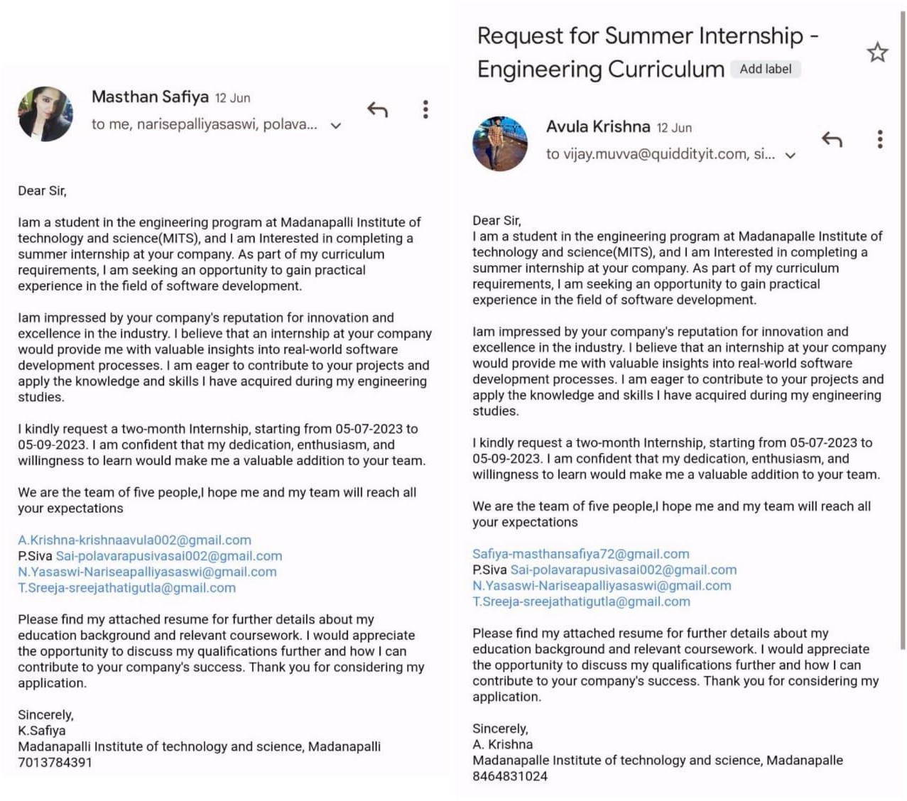
To Quiddity Infotech for Internship

This is the mail which we requested for the Internship from Quiddity Infotech.

Acceptance E-Mail
From Quiddity Infotech for Internship

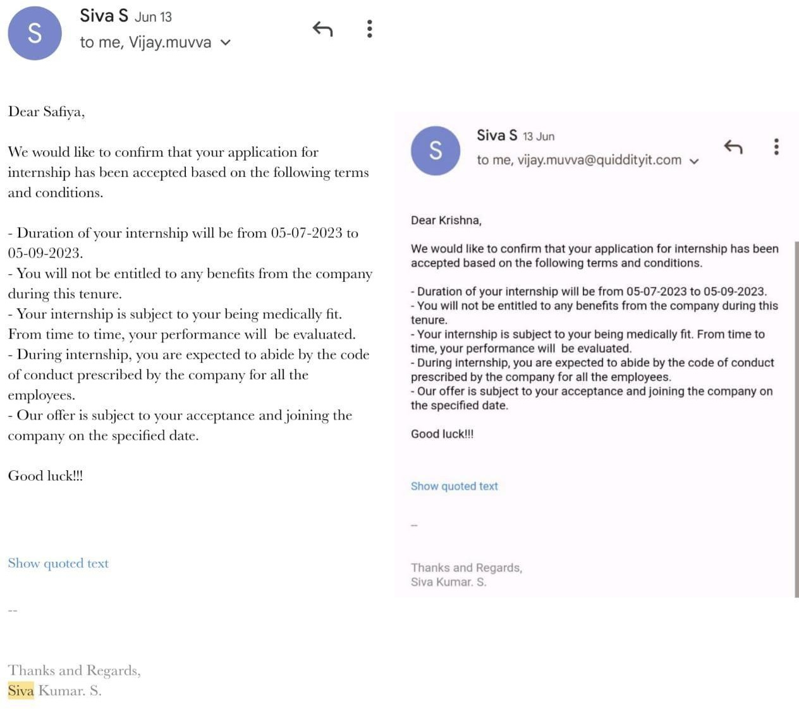

This is the mail which we received for the Internship from Quiddity Infotech.

Internship Certificate

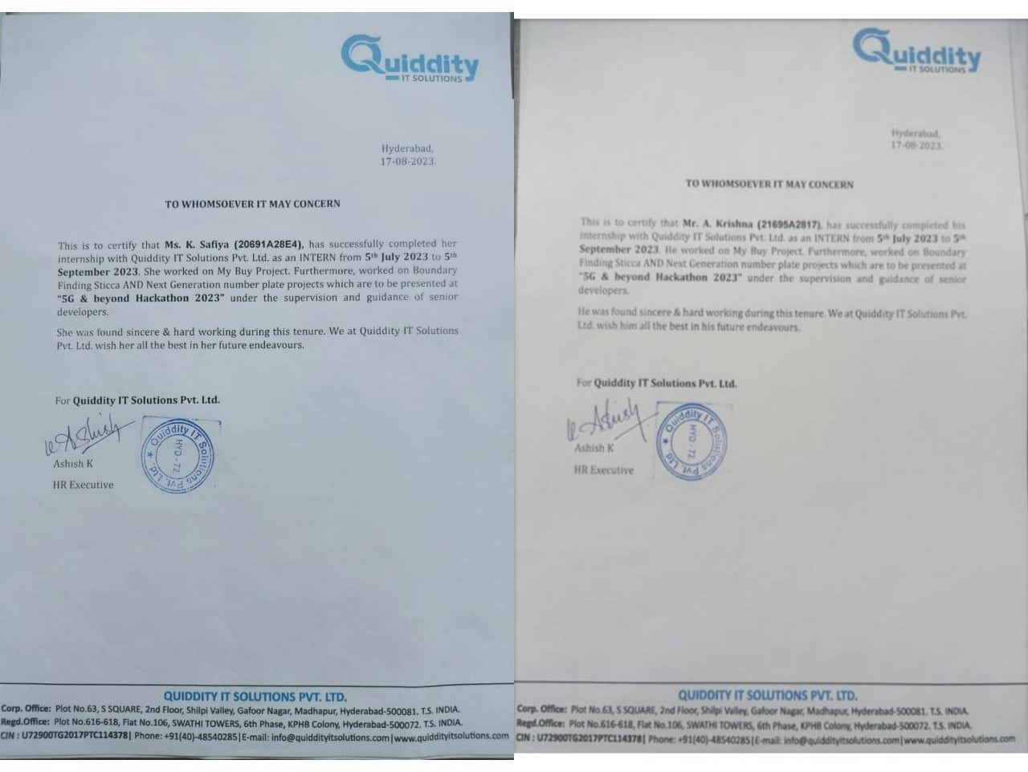

These are the Internship Certificates which we received from the Quiddity Infotech (5th July 2023 to 5th September 2023).

Official Mails assigned to us from the Quiddity Infotech
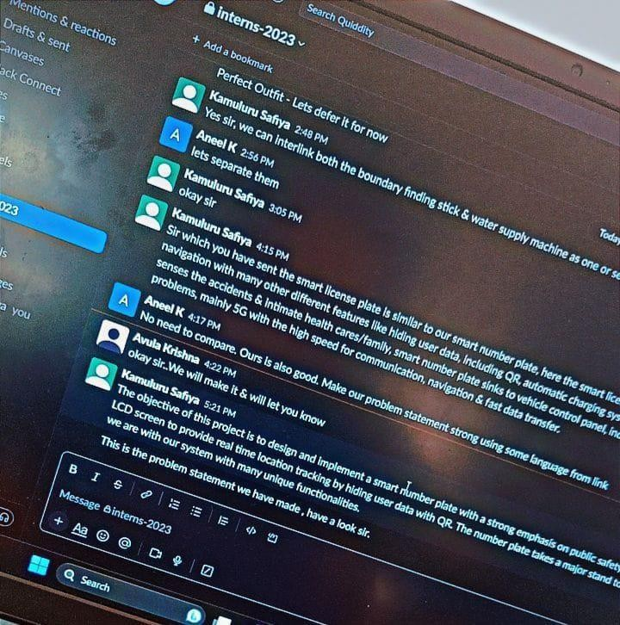
K.Safiya - safiya.k@quiddityinfotech.com A.Krishna - krishna.a@quiddityinfotech.com

Week Vise Working Process

Week 01 - Website Testing (My Buy), Creating and Developing the additional feature called Chatbot in application (My Buy) including several interfaces.

Week 02 - Developed the small application using web technologies and AIML (Spring boot)

Week 03 - 5G Hackathon project ideas discussion and started the initial step for the implementation.

Week 04 - Prepared all the ppts, pdfs, technical requirements and documents to be uploaded for the hackathon for all the 3 projects.

Week 05 - Among all 3 projects, 2 projects got selected, Started software & hardware development.

Week 06 - Implementing the 1 project of 2, almost 70% got finished, still working on hardware requirements and looking into 2nd project as well.

19-08-2023 to 05-09-2023 - Assigned some tasks to finish off (Work From Home Projects, Implementations)

These are the 2 months working details of our Internship.

Our Projects which we did during our Internship

- My Buy (Domain of Python & AI)
- Boundary Finding Sticca (Domain of Java & IOT)
- Next Generation Number Plate (Domain of Java)
- Aqua Stream Elite (Domain of Java)

First Day in the Office
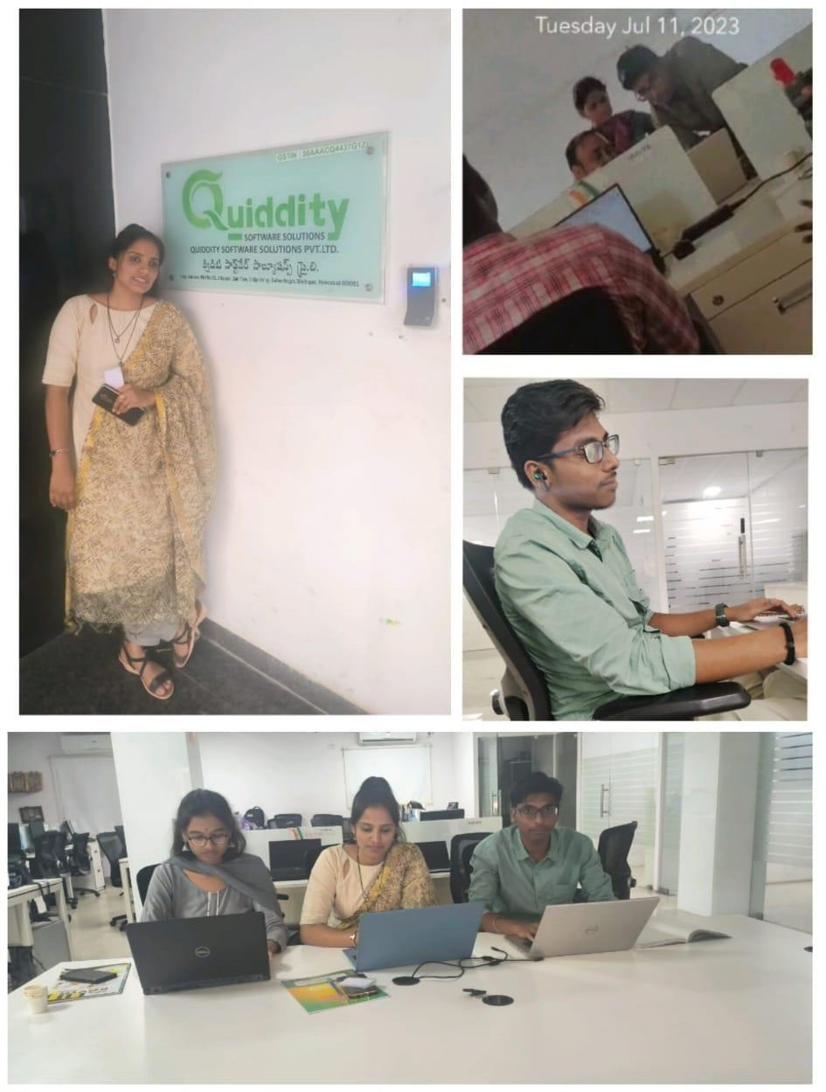
Website Testing (My Buy), Creating and Developing the additional feature called
Chatbot in application (My Buy) including several interfaces.

Got Trained in the Office about Spring-Boot
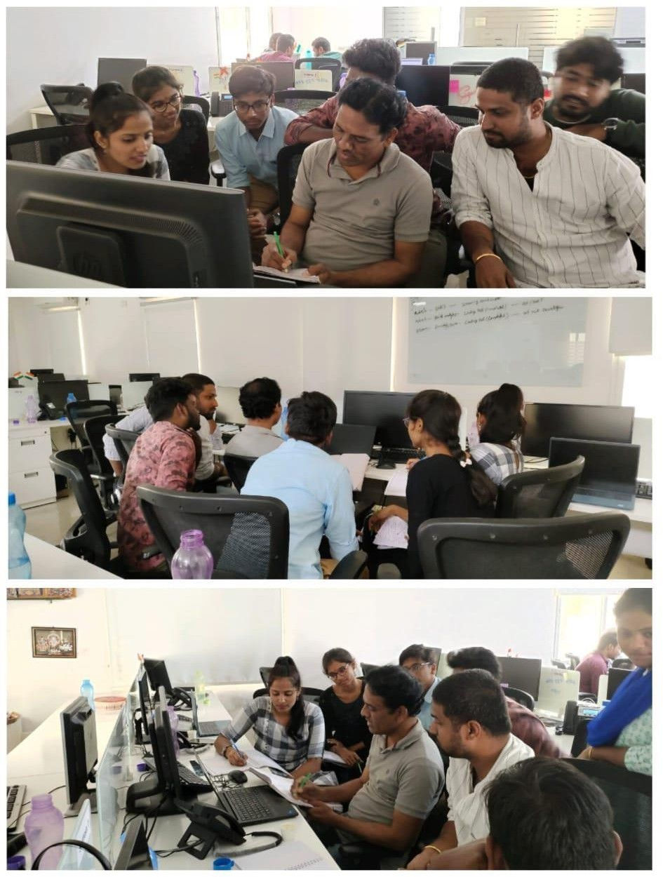

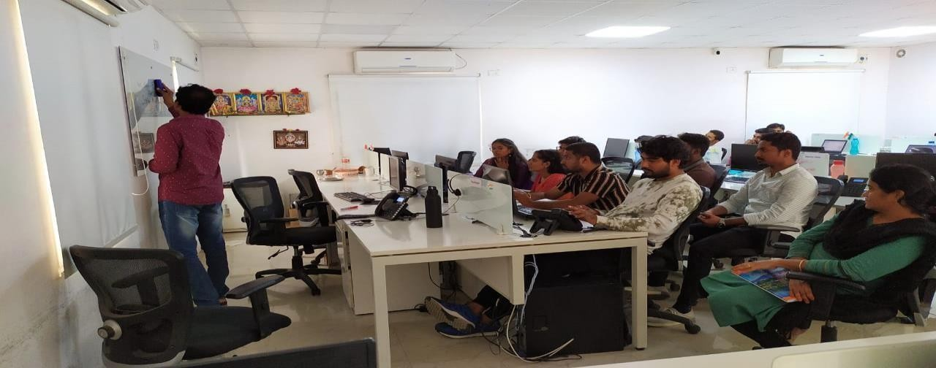
Got interacted with all the members at office and worked on basic needs of the project which is ongoing in the office (MYBUY) and got trained in the JAVA.

Discussion about the Projects with the CTO (Online Mode)
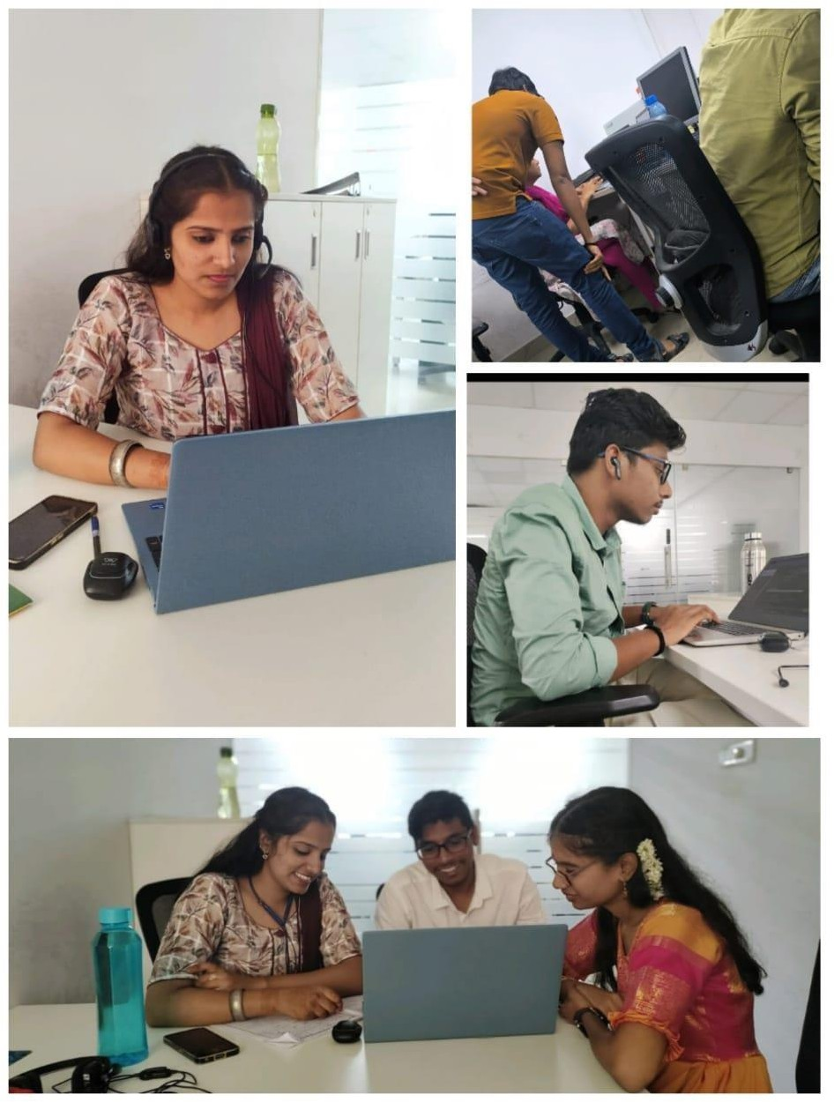
Discussed about the MYBUY project on developing the Chat-Bot based on the
Client Requirements.
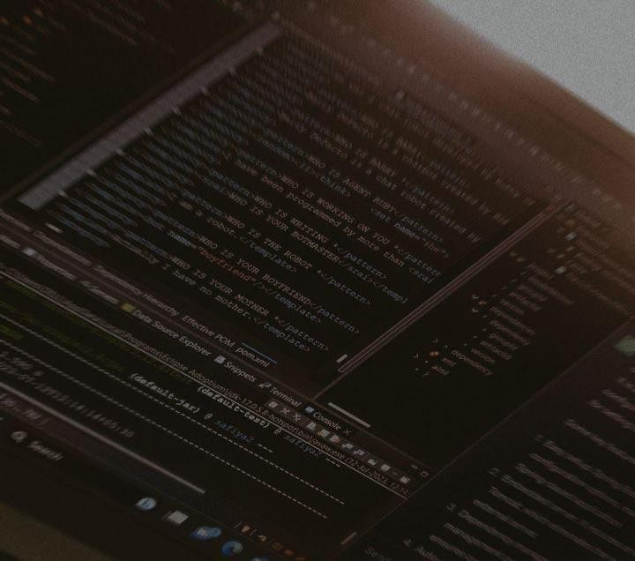

Took part in the celebrations of Independence Day in the Office
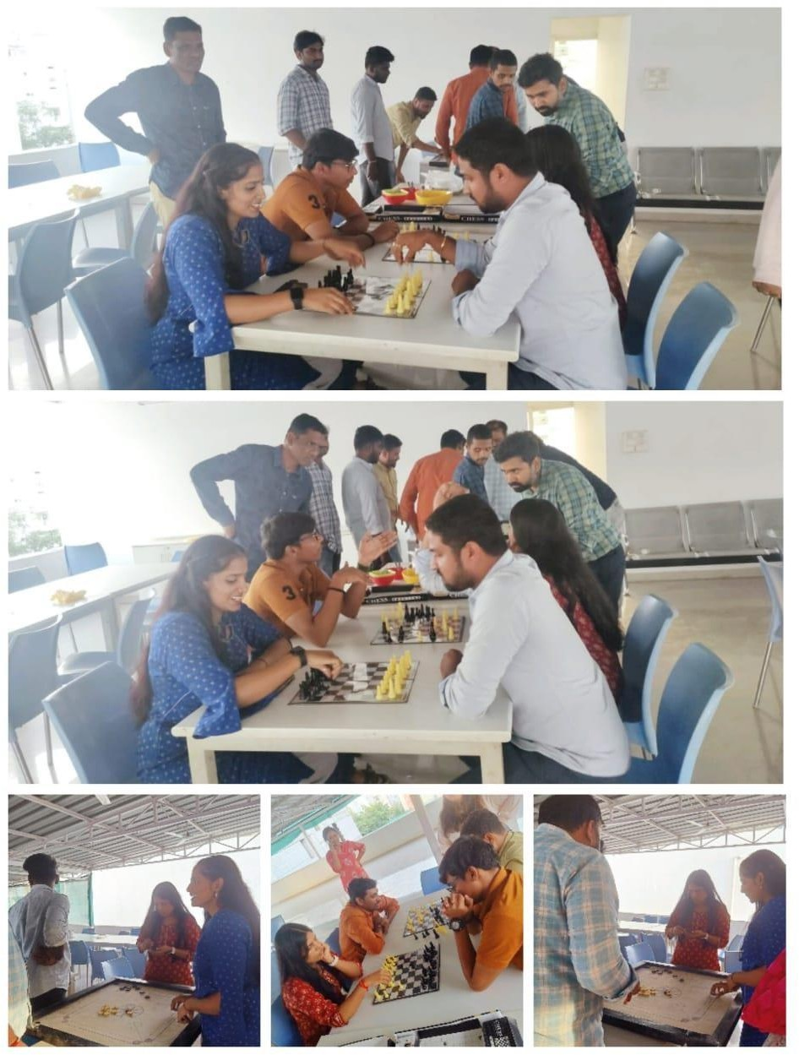
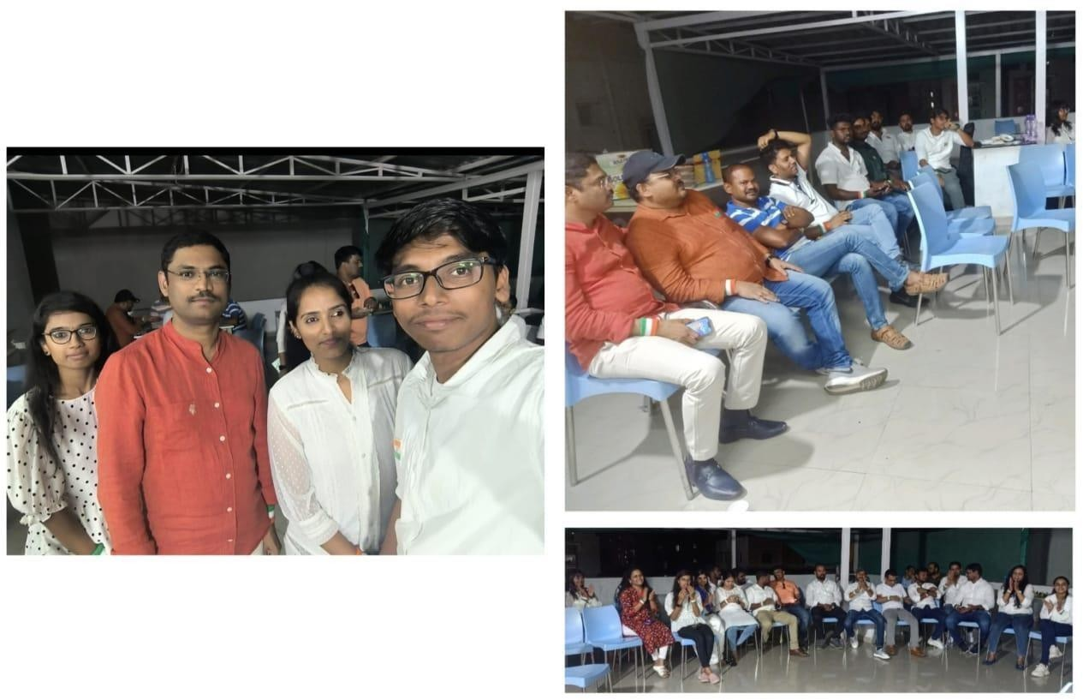

The Founder of Quiddity Infotech Mr. Vijay Kumar Sir, Our Project Manager
Mr. Siva Sir, Our CTO Mr. Aneel Sir.

So glad to be the part in every aspect in the Company.
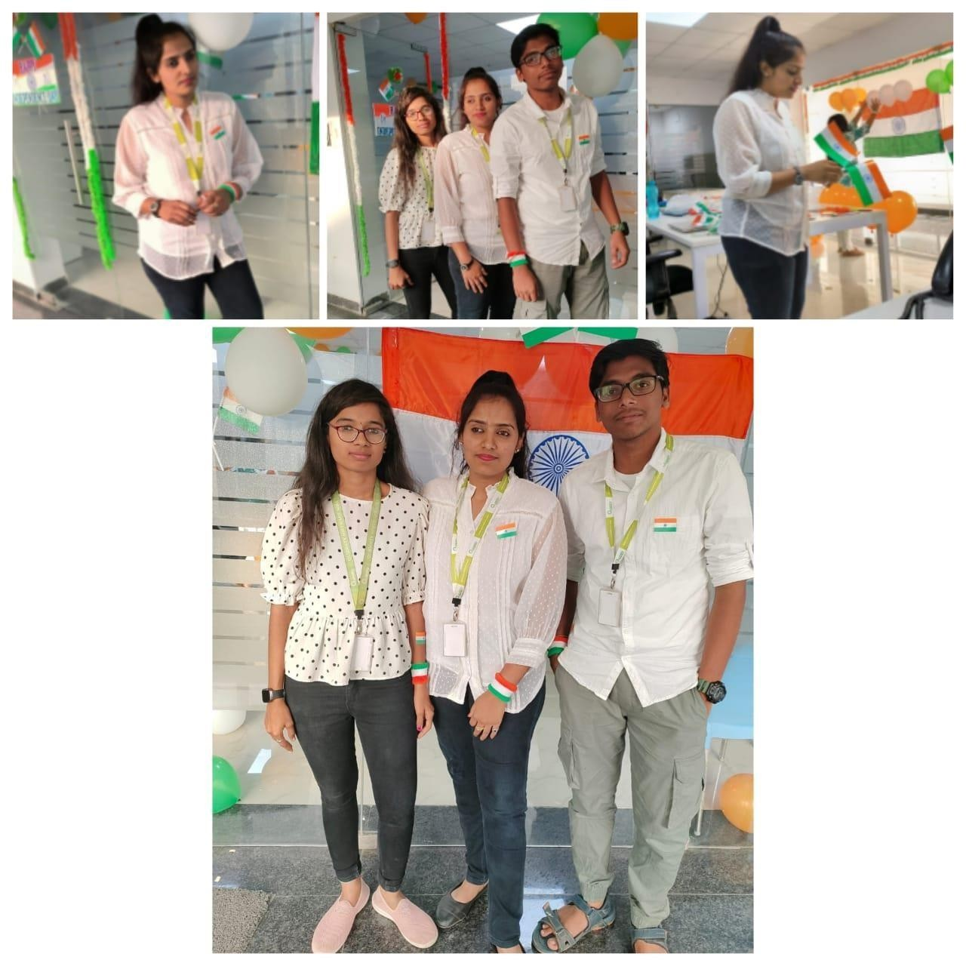
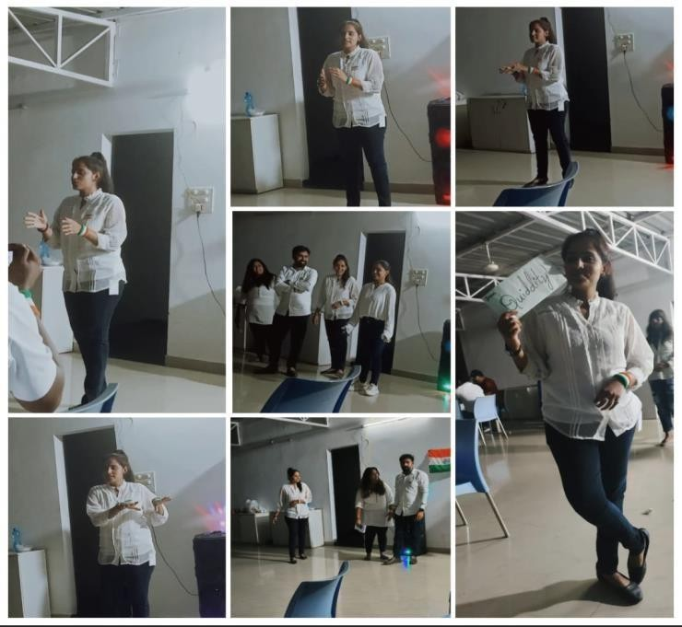

Gave the Gratitude Speech
Won the Voucher for the Unique representation.
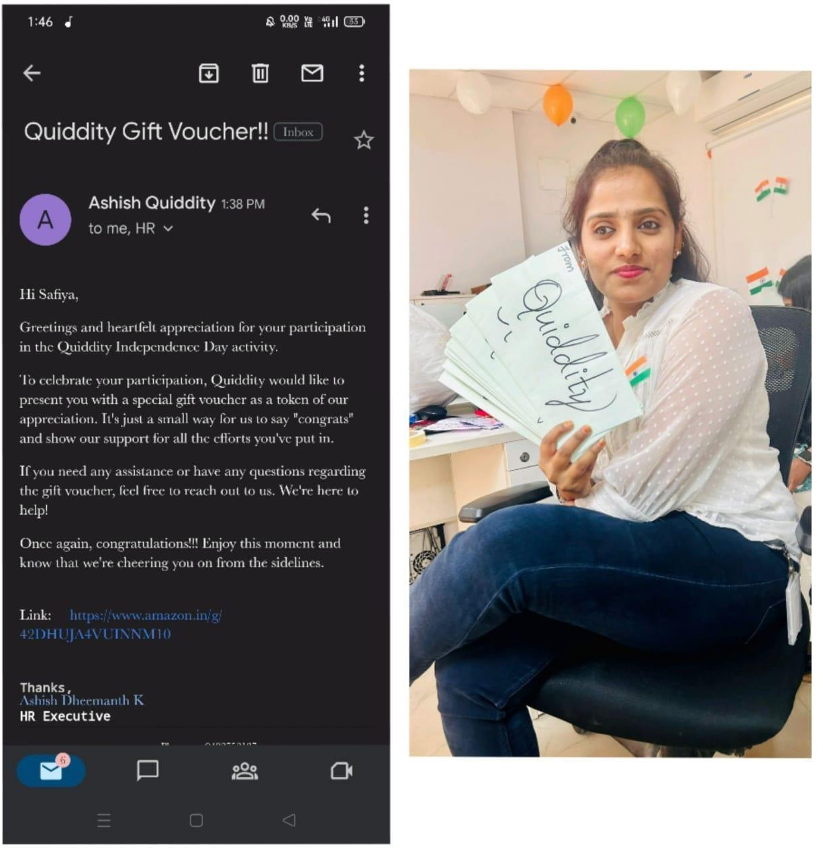
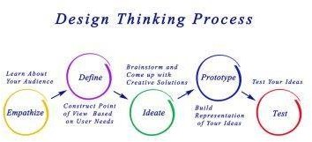

Implemented the Design Thinking methodology.

Projects
- Worked on the Project “Next Generation Number Plate” Here is the POC.
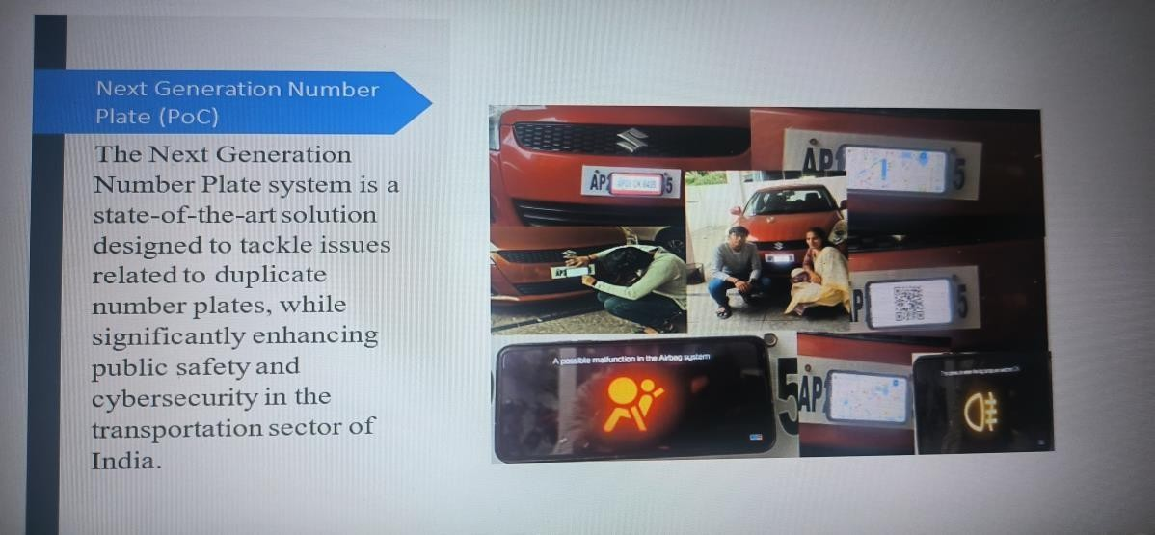
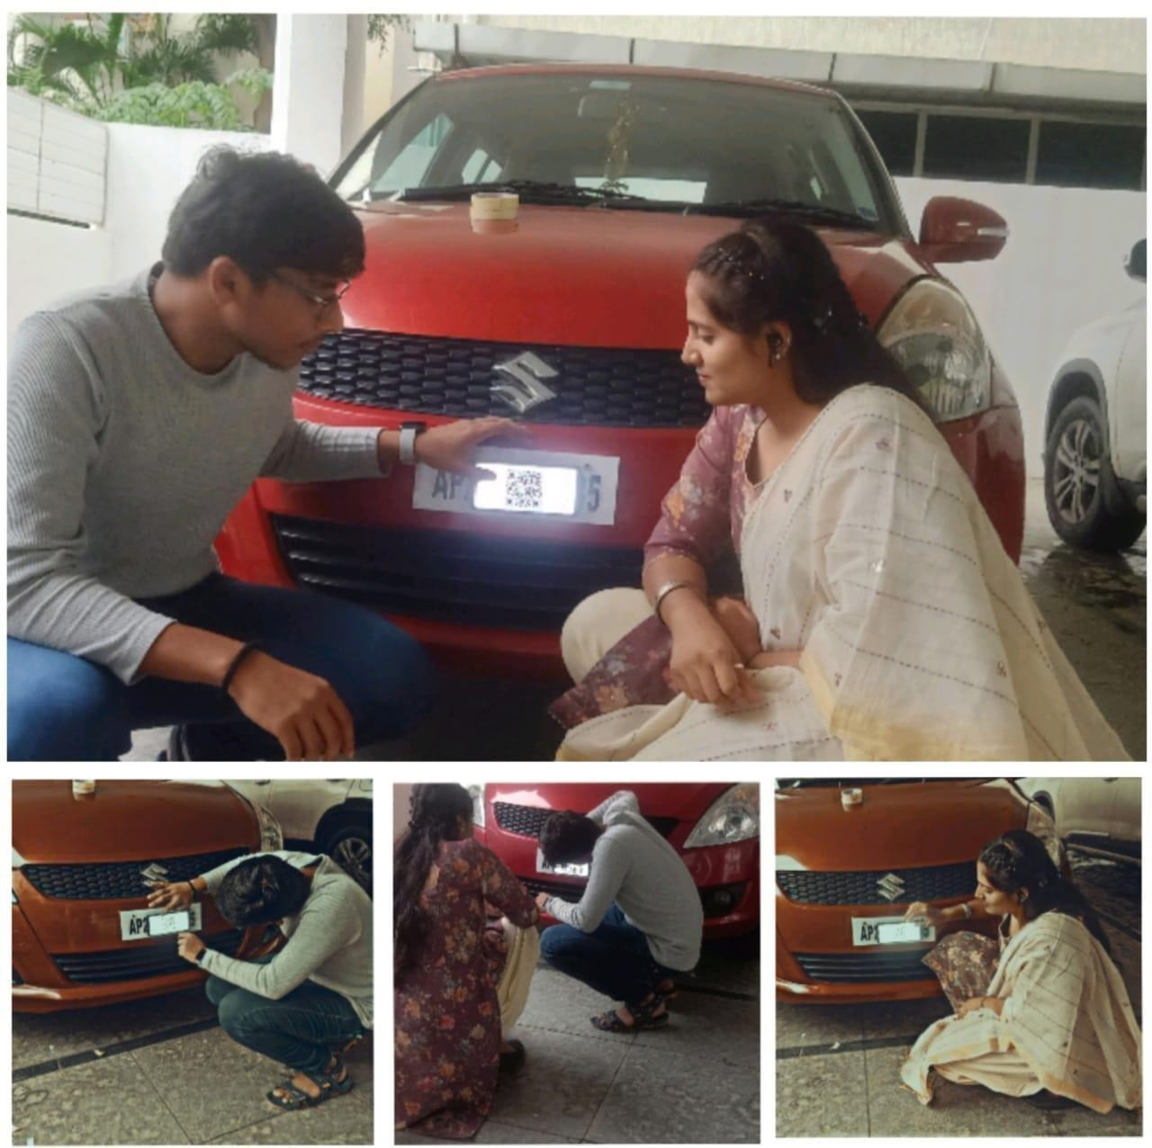

This is the project of security in the domain of “Java” 2.Worked on the project “Aqua Stream Elite”.
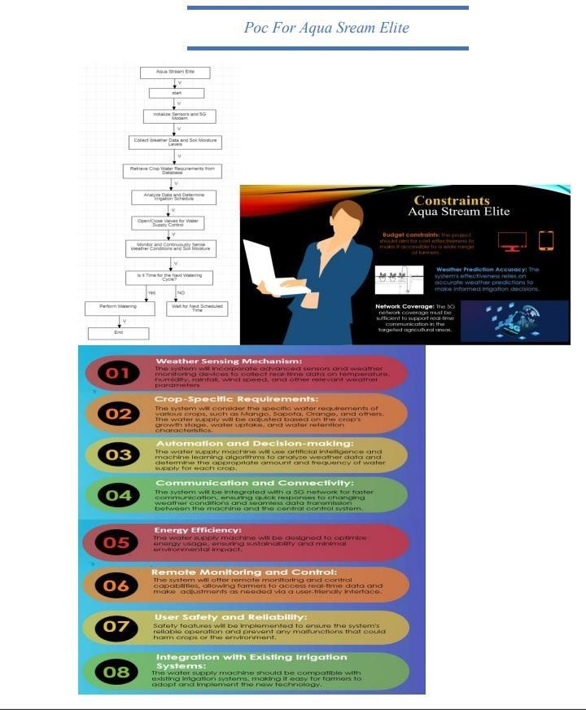
3.Worked on the project “Boundary Finding Sticca”.
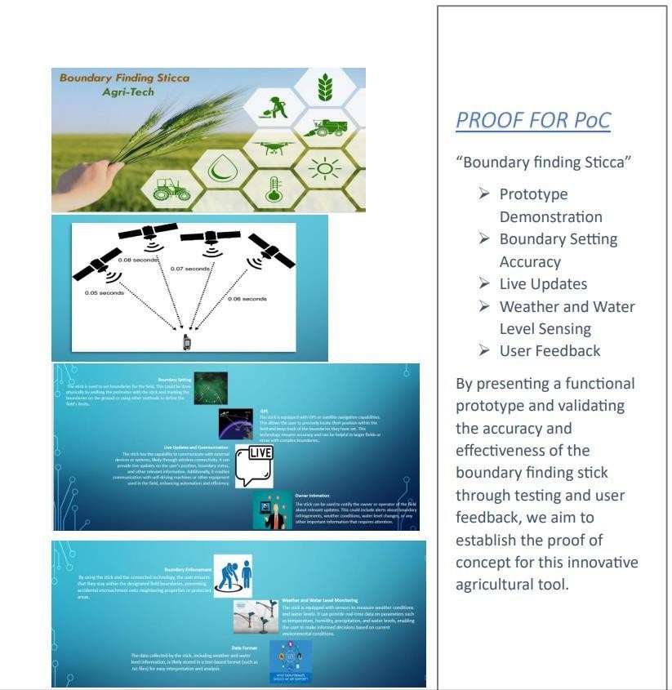

Here comes to the main module of the Internship. We have submitted all the 3 projects to the IMC but only the “Boundary Finindg Sticca” the Krishna’s idea got shortlisted and here we go with the working process

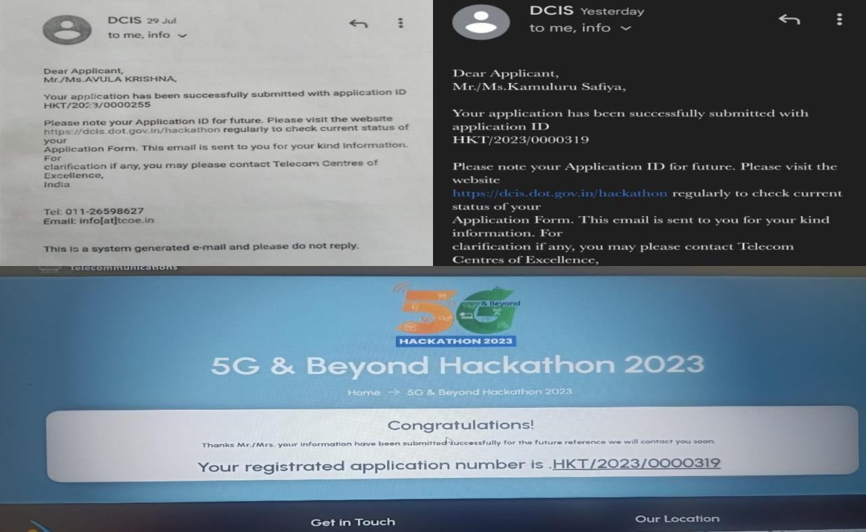
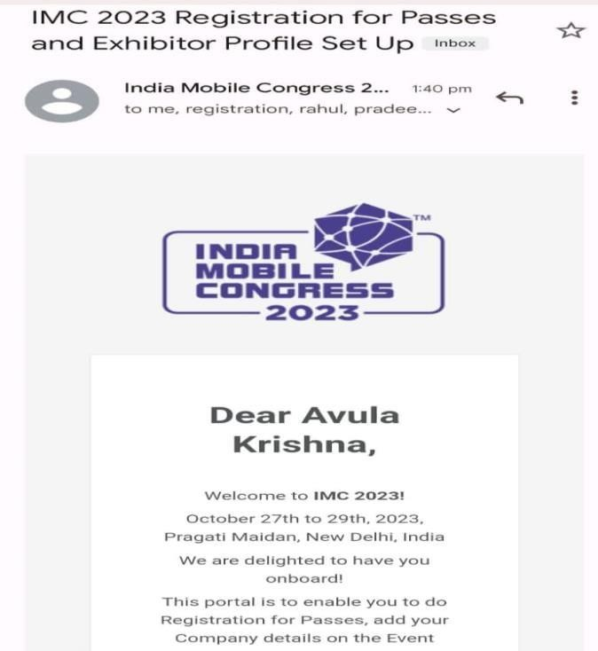
Applied for the IMC

Got the Confirmation setup

Received the Invitation from IMC
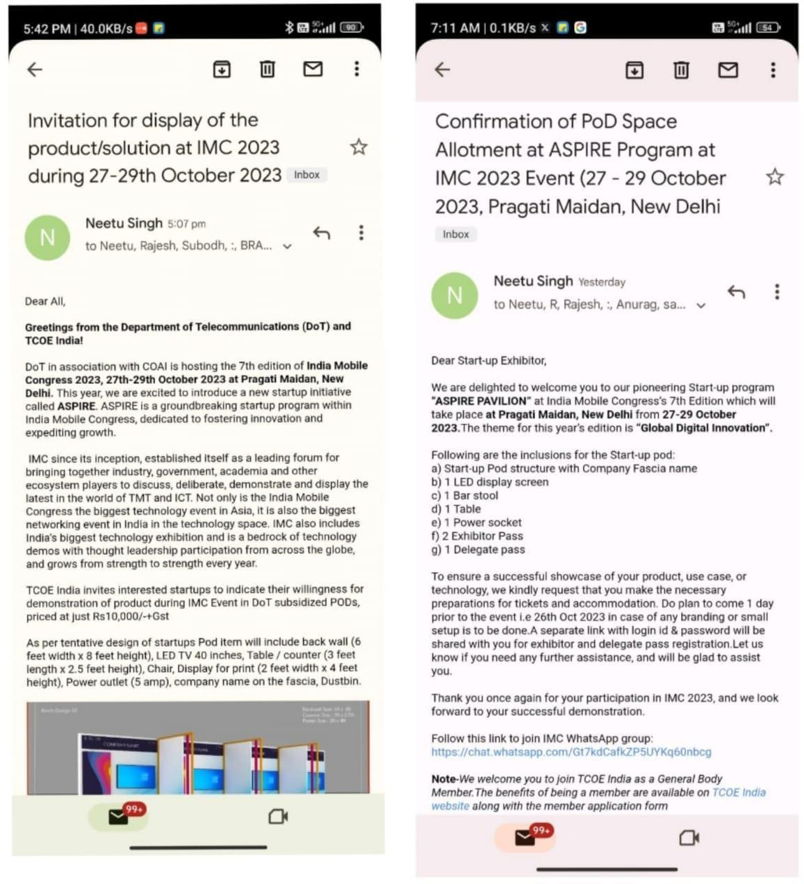

Got the Confirmation mails and confirmation about the POD details

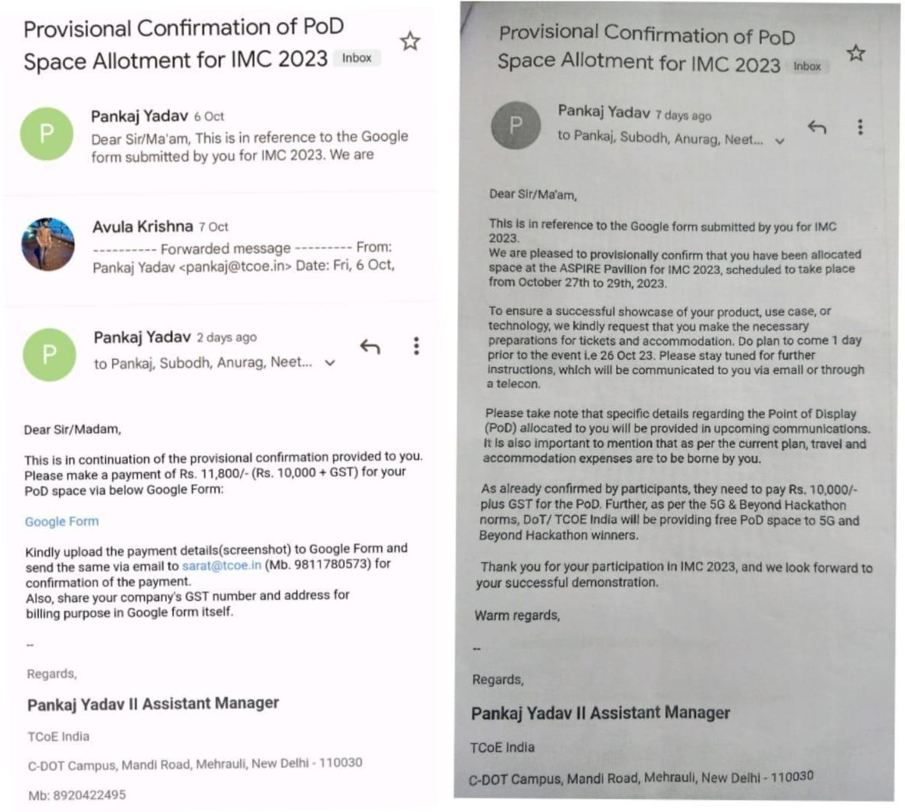
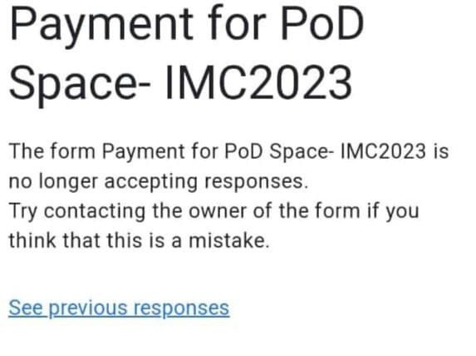

Payment Rs.10,000 paid by the CTO K. Aneel sir in the company and as well for the entry passes for 5 around Rs.9000.

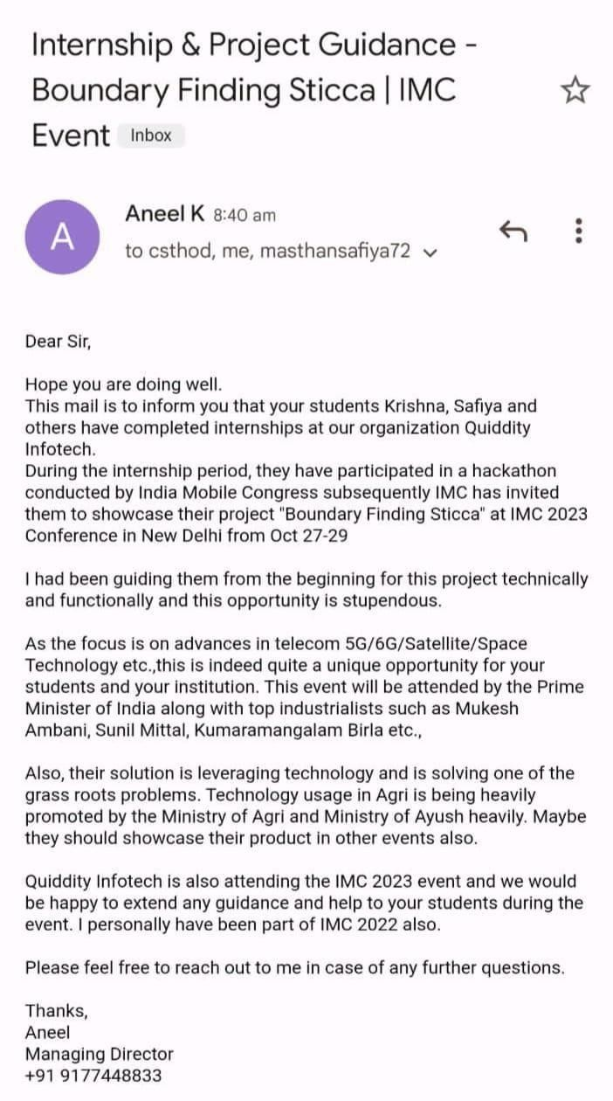
Aneel Sir confirmation with our HOD Dr.M.Sreedevi Mam

Our Project “Boundary Finding Sticca”
ABSTRACT
In the field of modern agriculture, accurately defining and managing field boundaries is crucial for optimal resource utilization and efficient crop management. However, the traditional methods of setting boundaries lack precision, often leading to encroachments onto neighboring lands. Additionally, farmers face challenges in obtaining real-time information about their fields and struggle to monitor changing weather conditions and water levels effectively. To address these issues, we propose the development of a Boundary finding Sticca equipped with advanced GPS navigation, satellite image integration, and weather and water level sensing capabilities. The goal of this innovative tool is to revolutionize field boundary setting and management.
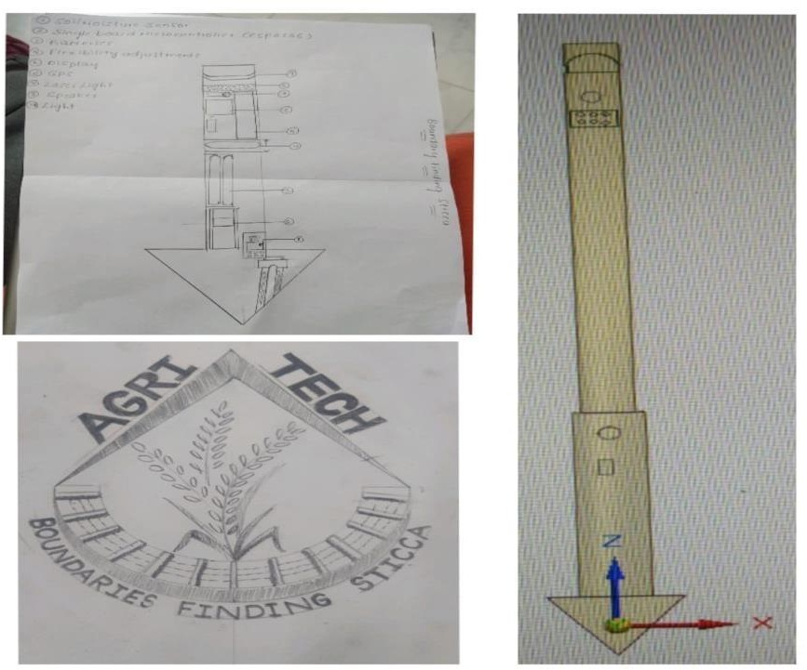
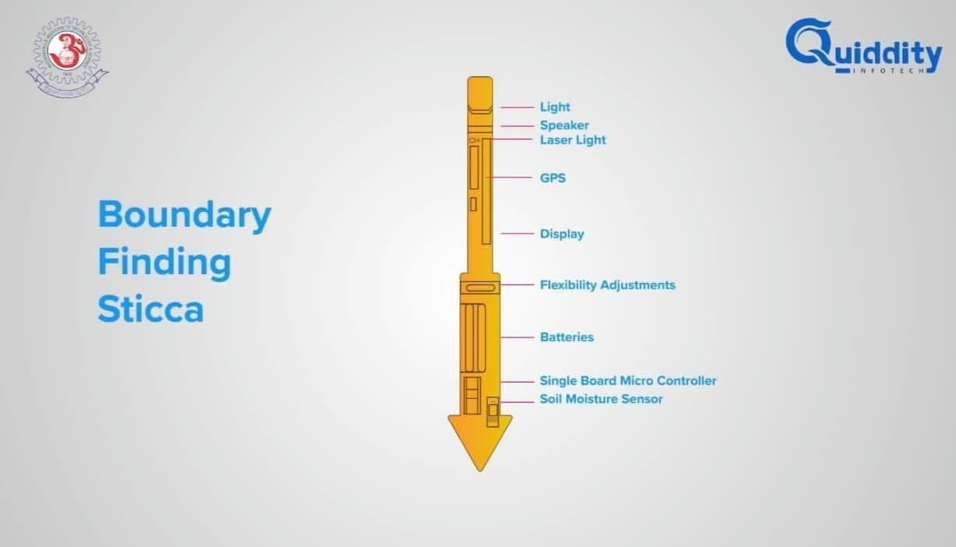

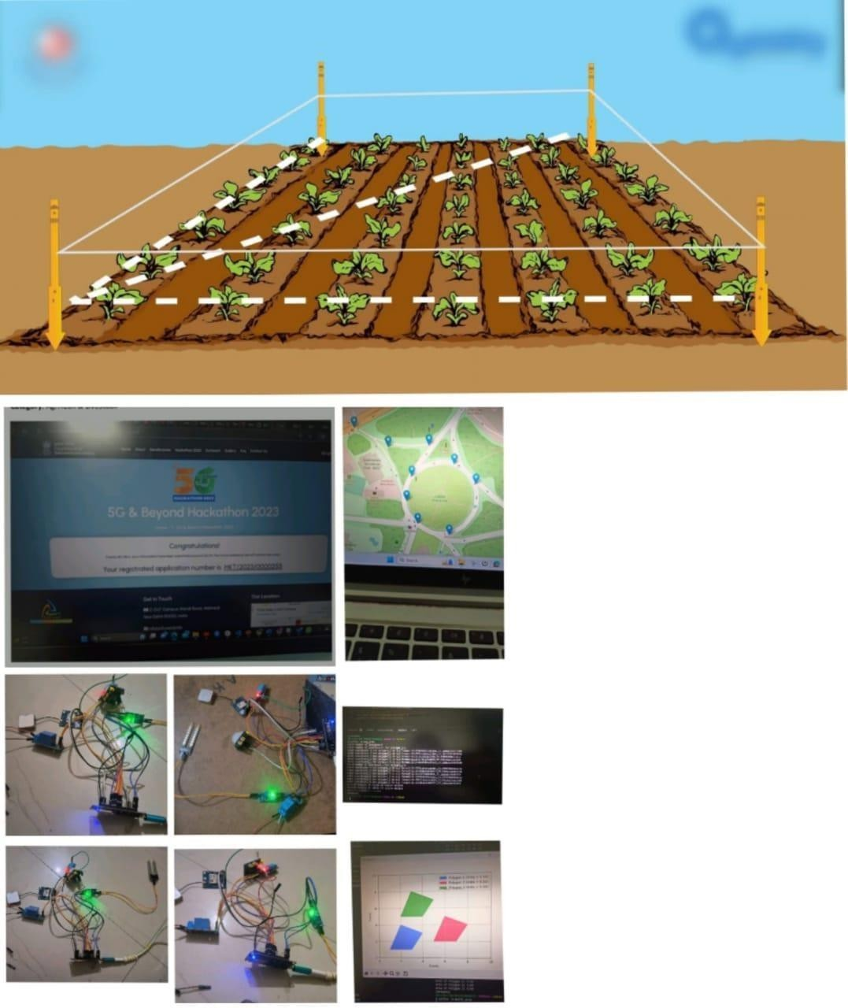
Working Methodologies

Received main 2 Exhibitor passes and 1 Delegate pass
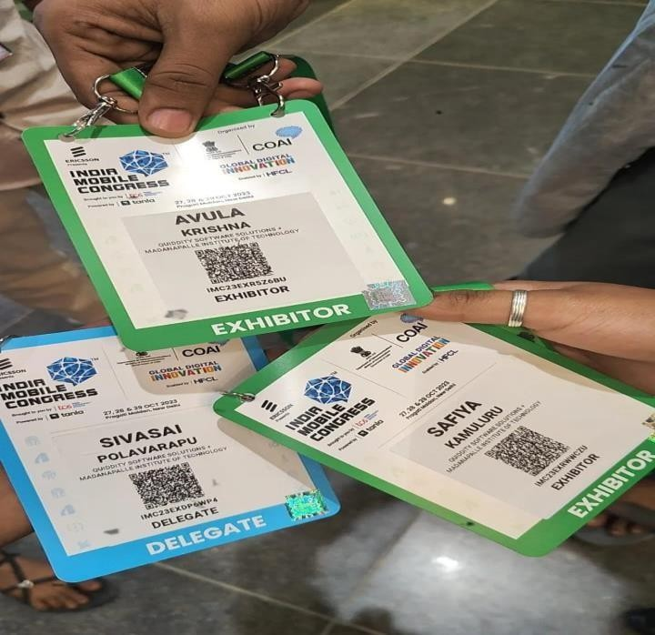

Represented MITS at the The 7th edition of Asia's premier technology exhibition, India Mobile Congress (IMC), co-hosted by the Department of Telecommunications (DoT) and Cellular Operators Association of India (COAI), which was held from 27th-29th Oct at Pragati Maidan, New Delhi.
The Main Exhibitors with the Main Roles
1.A.Krishna
- K.Safiya
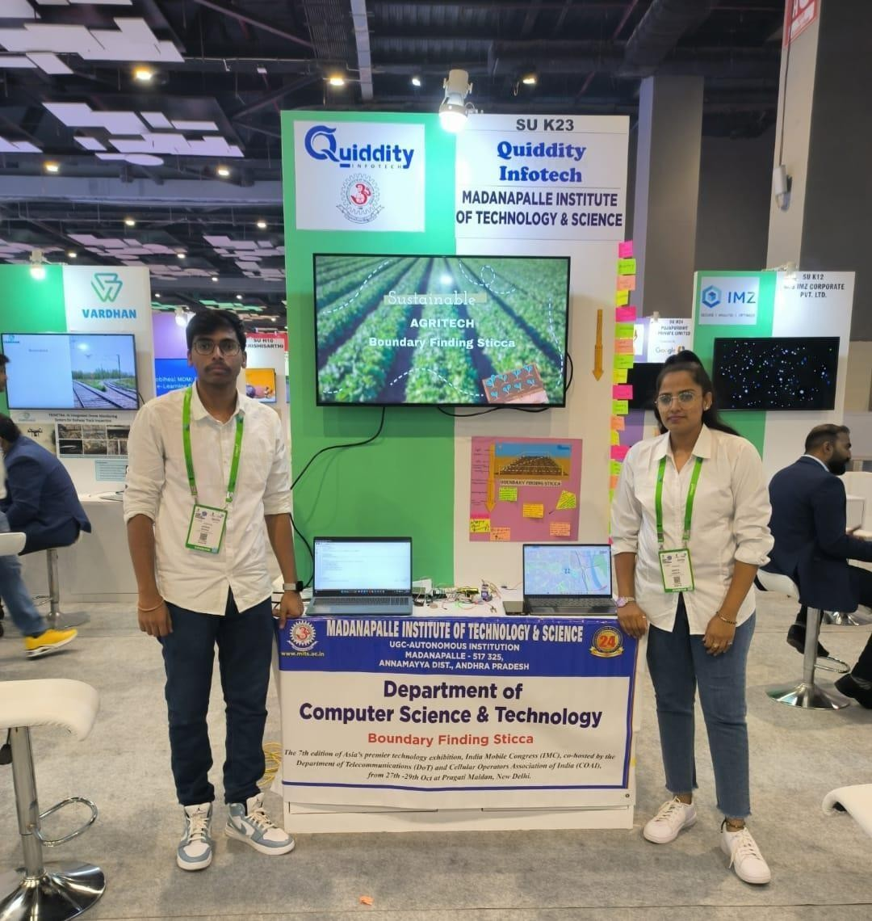

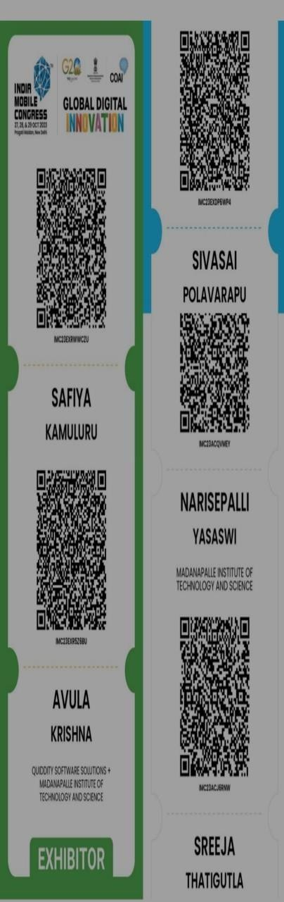
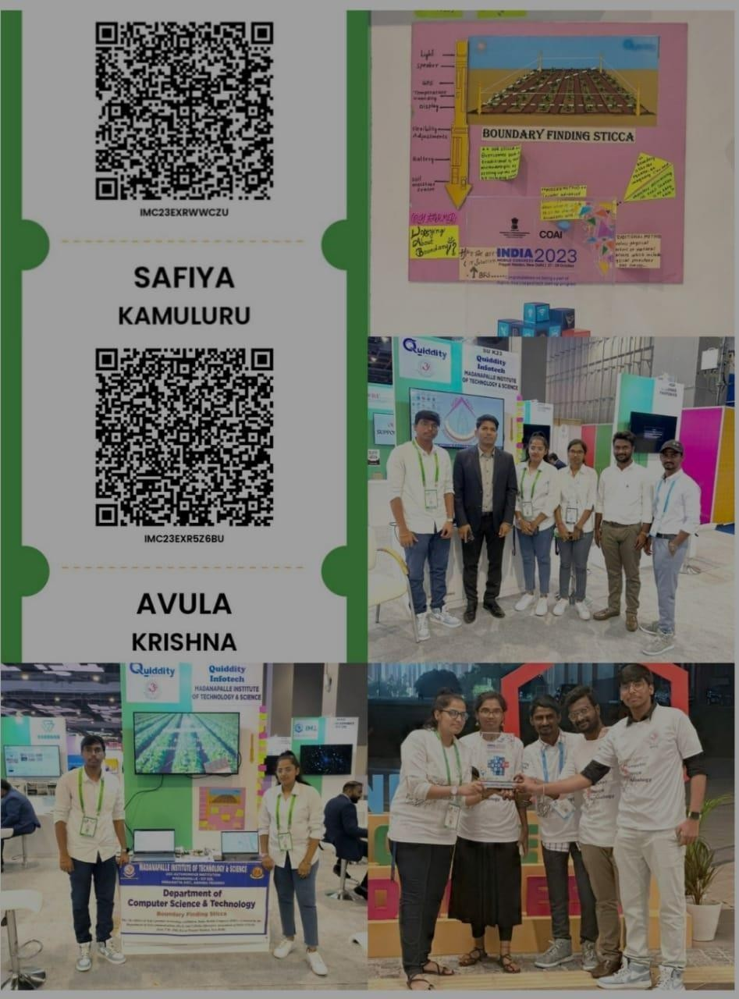
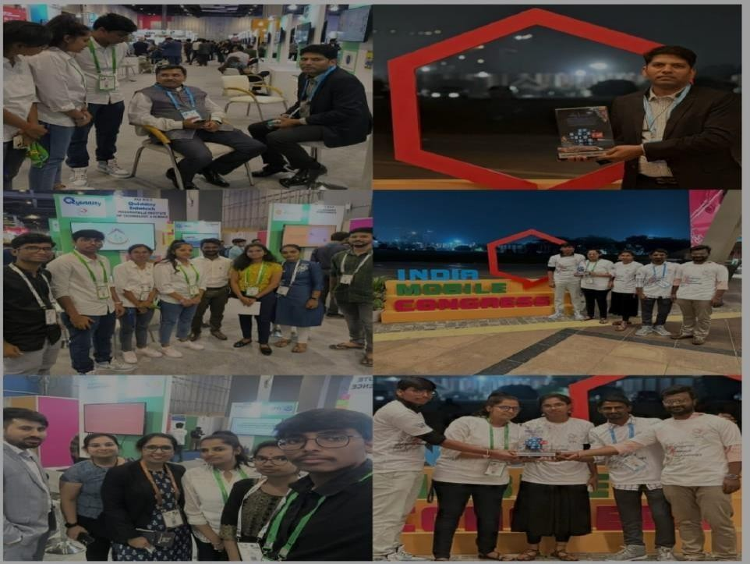
Our Entry Passes

Gained a lot of experience by talking with all the experts and as well received many offers from them.

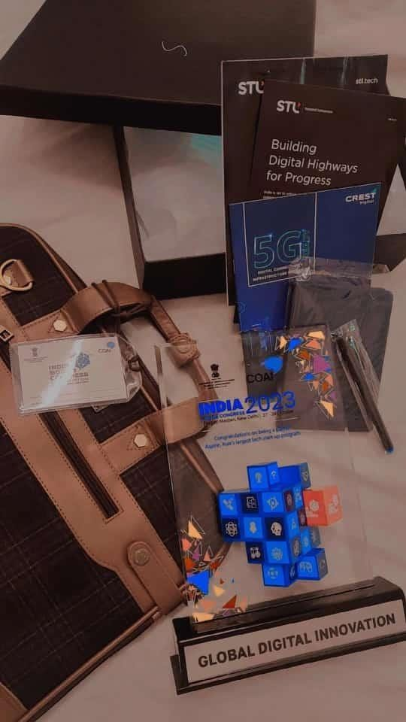
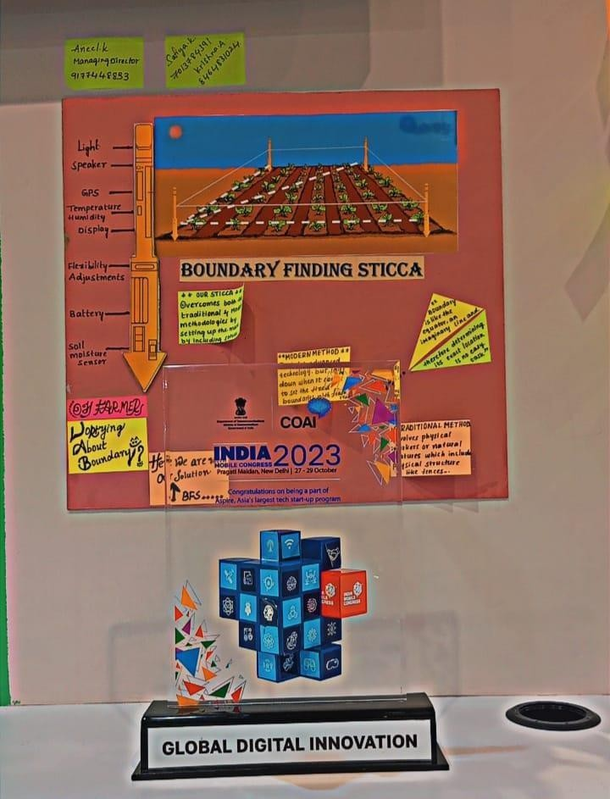
Won the 2nd Place Award in the Agriculture Sector, and free entry passes for upcoming 2 years IMC event So proud as the MITSIAN over IMC

ANEEL CTO, KRISHNA EXHIBITOR, SAFIYA EXHIBITOR names on the POD

Our Success got published more than 7 magazines

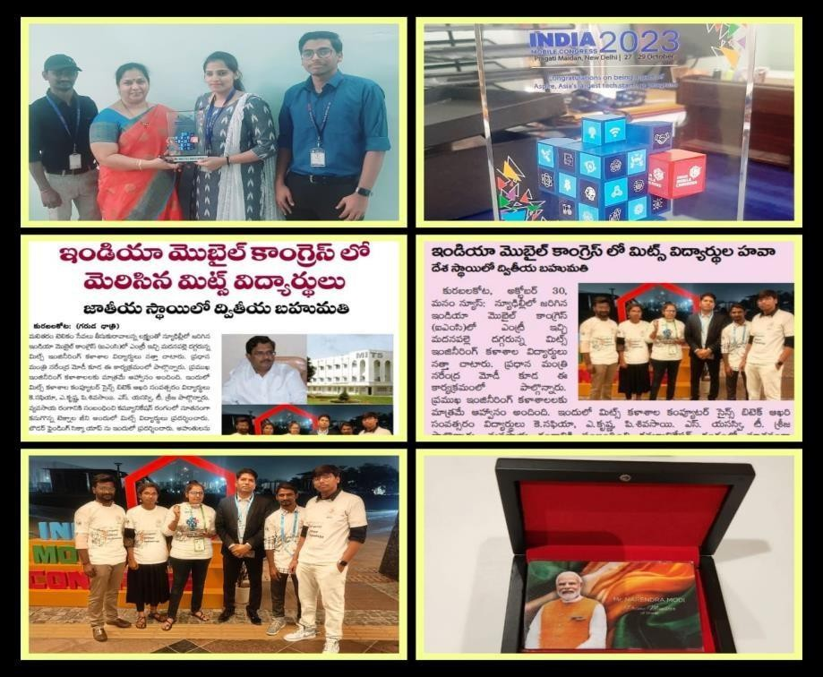
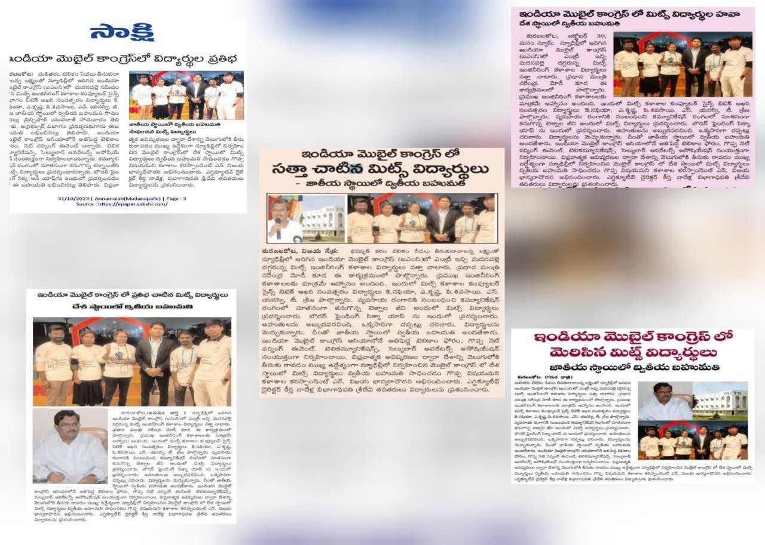

Finally Our Hard work in Our Hands
Representation of our MITS over Asia’s Biggest Event is the proudest feeling ever
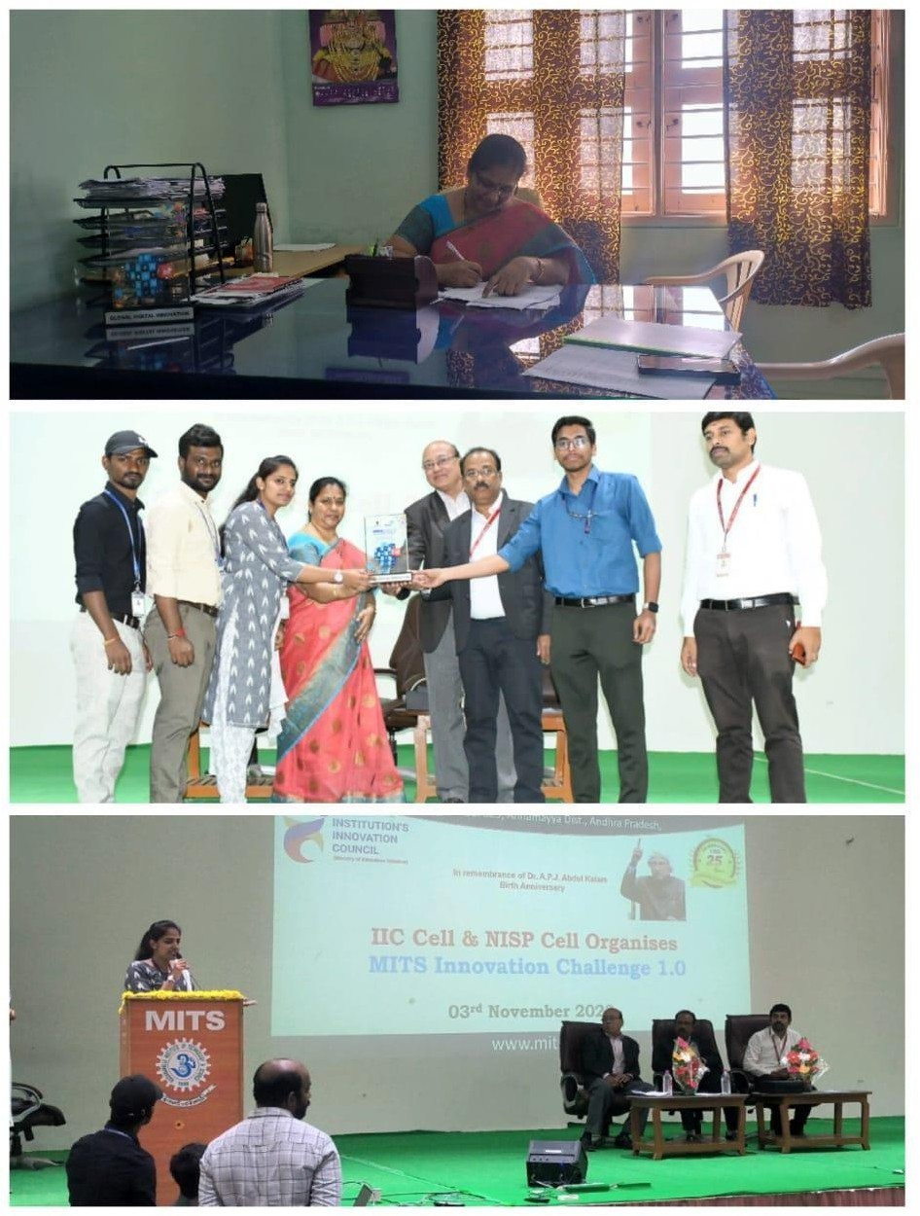

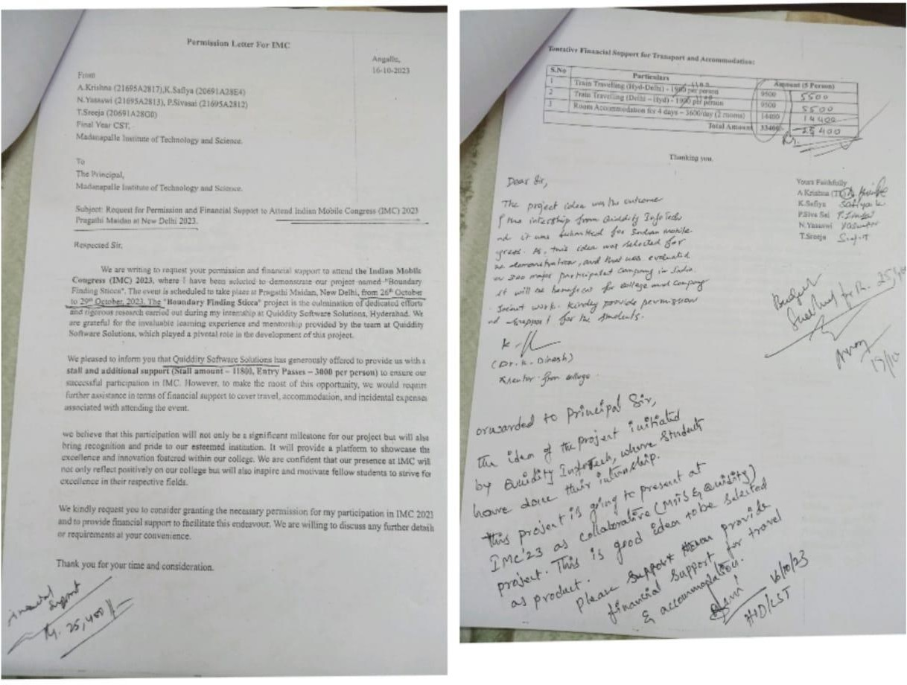
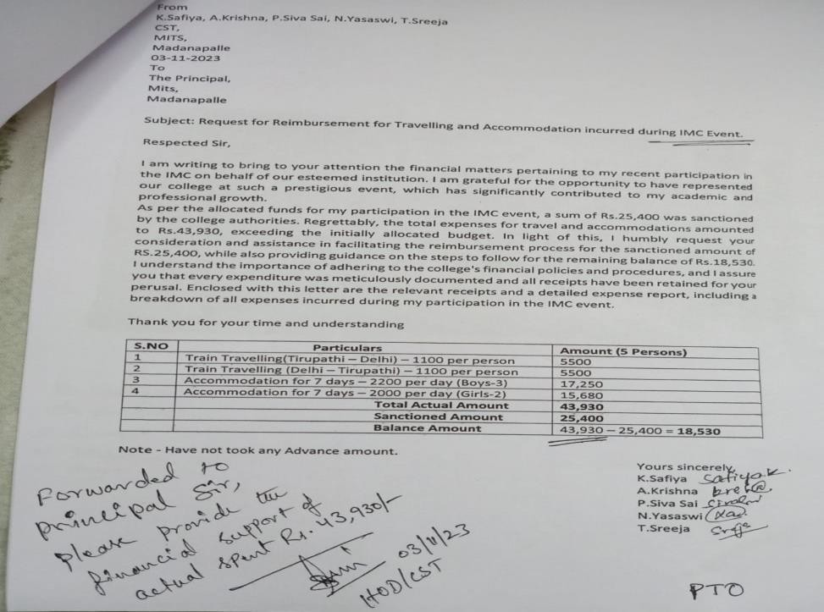
Financial Support from the College upto Rs.25,400

Our Heartful thanks to our Dr.M Sreedevi mam the HOD of CST department. Madam trusted us and she stood at the top by supporting us. Thank you so much for all your support mam.

The wonderful send off by the Quiddity Infotech
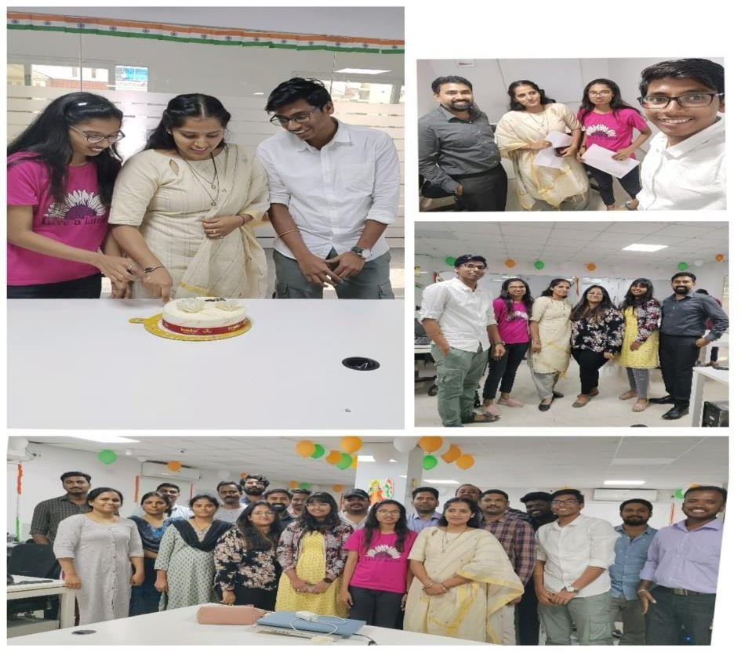
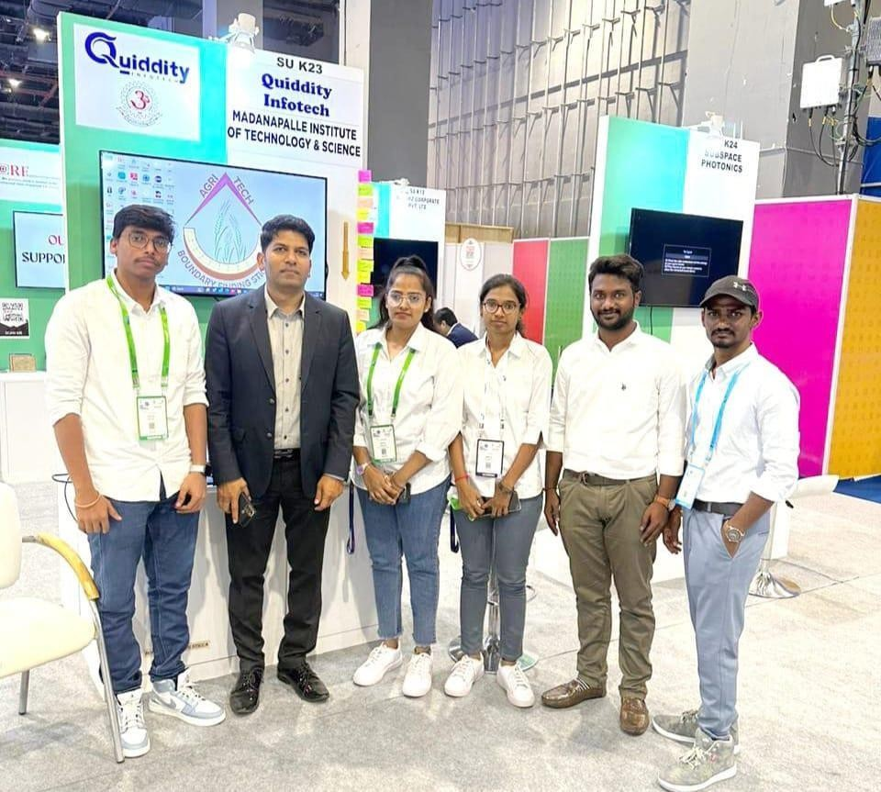

From Company to IMC at Delhi. The Journey of Success core hearted thanks to the Mr.K.ANEEL SIR, Dr.M.SREEDEVI MAM and A.KRISHNA THE TEAM
LEAD with the K.SAFIYA THE TEAM PLAYER and the TEAM.
THANK YOU

JOURNEY TO BE CONTINUED

